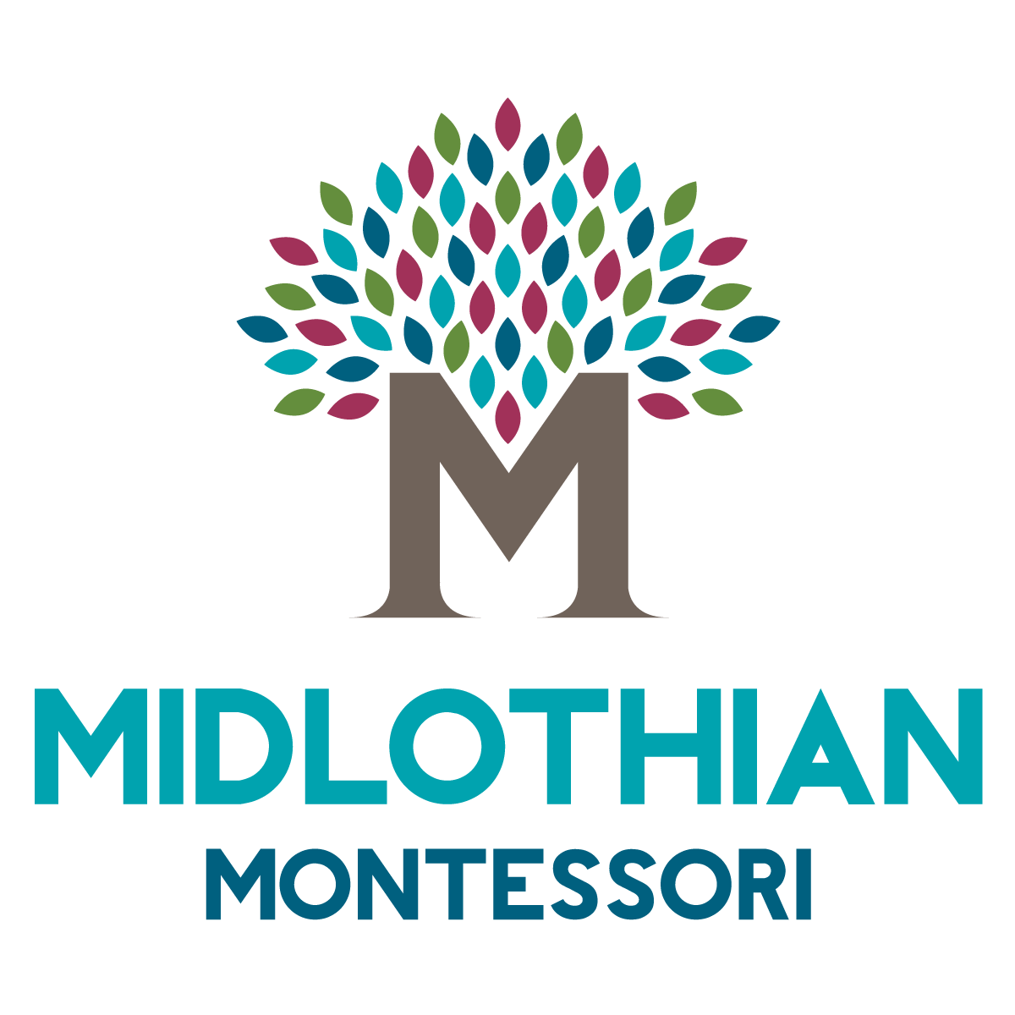

2020-2021 Enrollment Contract

Midlothian Montessori reserves a place for ___________ in the program selected provided this contract is completed in entirety and a full non-refundable payment of $420 for the enrollment fee is received.

I have selected the following program:
- Primary I: $5690 Tuition and $380 Material Fee
- Primary II / Extended Day: $7695 Tuition and $380 Material Fee
- Primary III / Kindergarten: $7695 Tuition and $380 Material Fee
- Elementary: $8990 Tuition and $380 Material Fee

I have selected the following payment plan:
- Early-Pay: 6 % discount (by May 22nd, 2020)
- Pre-payment: 4 % discount (by September 1, 2020)
- Installment: 3 Payments due September, December, March
- Monthly: 9 Payments due by the 5th of the month ($10 fee per month)

Each family is asked to contribute ten service hours of time to the school per enrolled student (max of 20.) Parents are required to attend parent orientation and one parent night per year. Three hours (total) will be given for these requirements. The remainder of the service hours can be filled through various volunteering opportunities listed during Parent Orientation or parents may opt to pay $15 per unfulfilled hour.

I ________________________________________ (Parent) agree to pay Midlothian Montessori, LLC the net tuition for my child for the 2020-2021 school year. I understand that my obligation to pay tuition exists throughout the above academic year (Sept.-June), and that the departure of my child in no way diminishes the expenses of the school; therefore, my obligations remain for the academic year. No portion of fees will be refunded, transferred, or canceled in the case of absence, withdrawal or dismissal.


_____________________________ ________
Signature of Parent or Legal Guardian Date

_____________________________ ________
Signature of Director Date


Midlothian Montessori School | mail@midlomont.com | www.midlomont.com
122 N. Courthouse Rd. Richmond, VA 23236 (804)794-8661

